International Journal of Applied Computer Science Methods:
Authors’ Instructions for the Preparation
of the Submission Format of the Final Version
of the Manuscript
Jacek M. Zurada¹, Andrzej Cader², Krzysztof Przybyszewski²
¹ Department of Electrical and Computer Engineering
University of Louisville, Louisville, KY, USA
jacek.zurada@louisville.edu
² IT Institute, Academy of Management, Lodz, Poland
(acader, kprzybyszewski)@swspiz.pl
Abstract
The abstract should summarize the content of the paper and should contain at least 50 and at most 120 words. It should be set in 9-point font size and should be inset 1.0 cm from the right and left margins. Following the abstract, at least three and up to six keywords should be included. The keywords must characterize the subject of the paper and assists in indexing.
Key words: JACSM, authors’ instructions, submission format, MS Word template
1 Introduction
Authors are invited to submit original papers, within the scope of the JACSM, with the understanding that their contents are unpublished and are not being actively under consideration for publication elsewhere.
For any previously published and copyrighted material, a special permission from the copyright owner is required. This concerns, for instance, figures or tables for which copyright exists. In such a case, it is necessary to mention by the Author(s), in the paper, that this material is reprinted with the permission.
Manuscripts, in English, with an abstract and the key words, are to be submitted to the Editorial Office in electronic version (both: source and pdf formats) via e-mail. A decision to accept/revise/reject the manuscript will be sent to the Author along with the recommendations made by at least two referees. Suitability for publications will be assessed on the basis of the relevance of the paper contents, its originality, technical quality, accuracy and language correctness.
Upon acceptance, Authors will transfer copyright of the paper to the publisher, i.e. the Academy of Management, in Lodz, Poland, by sending the paper to the JACSM Editorial Office.
The papers accepted for publication in the JACSM must be typeset by their Authors according to the requirements concerning final version of the manuscripts. However, the publisher reserves the right to do minor corrections deemed necessary.
2 Detailed Instructions
Acceptable paper length is between 10 and 25 pages. The printing area is 122 mm × 193 mm and the text must be written in a single column. Hence the margins of the A4 size page must be set as follows: top margin: 5,0 cm, bottom margin: 5,4 cm, left margin: 4,5 cm, right margin: 4,5 cm. The margins of the B5 size page must be set as follows: top margin: 3,0 cm, bottom margin: 3,4 cm, left margin: 3,1 cm, right margin: 2,9 cm. That is illustrated in Table 1 and (only for the A4 page) Fig.1.
Table 1. Set of margins at the B5 and A4 size page
Page size | Margin | Width [cm]
B5 | Left | 3,1
 | Top | 3,0
 | Right | 2,9
 | Bottom | 3,4
A4 | Left | 4,5
 | Top | 5,0
 | Right | 4,3
 | Bottom | 5,4

The text should be justified to occupy the full line width, so that the right margin is not ragged, with words hyphenated as appropriate. Please fill pages so that the length of the text is no less than 180 mm.
The first page of each paper should contain its title, the name of the Author(s) with the affiliation(s) and e-mail address(es), and then the abstract and keywords, as show above. Capital letters must be applied in the title of a paper, and 14 pt. boldface font should be used, as in the example at the first page. Use: 11-point type for the name(s) of the Author(s), 10-point type for the address(es) and the title of the abstract, 9-points type for the abstract and the key words.
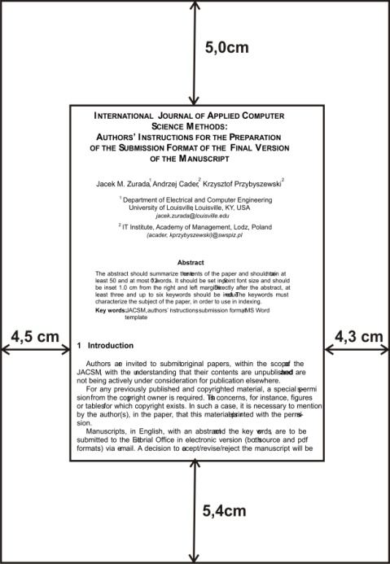
Figure 1. Illustration of the typing area and margins at the A4 size page
For the main text, please use 11-point type and single-line spacing. We recommend using Times New Roman (TNR) fonts in its normal format. Italic type may be used to emphasize words in running text. Bold type and underlining should be avoided. With these sizes, the interline distance should be set so that some 43 lines occur on a full-text page.
The papers should show no printed page numbers; these are allocated by the Editorial Office.
Figures and tables should be inserted in proper places throughout the text. They must be embedded in the text, within the typing area, not enclosed at the end of the paper. Figure with their captions, as well as tables with their titles, constitute integral bodies that must be placed as a whole at the same page.
Footnotes should be avoided, if possible. Acknowledgements may be included at the end of a paper, not in footnotes.
Section and subsection headings cannot end a page. In such a case, they ought to be moved to the first line of the typing area at the next page.
2.1 Sections and Subsections
Headings and subheadings for different sections must be clearly indicated and numbered appropriately (except the References, Appendices, and Acknowledgments).
The first section should be the Introduction. The Introduction section should portray the broad significance of the paper and explain what is new and original.
The last section should be the Conclusions. The Conclusions section usually ought to clearly summarize the range of applicability of the methodology described in the article. It may also recommend directions of further research.
2.2 Figures and Tables
Figures and the tables should be centered, and numbered consecutively. Figure captions must be placed below the figures and table titles – above the tables; both in 10pt. font size (like at Table 1 and Fig.1 above).
The figures should be in JPEG or TIFF format and paste with appropriate size into the manuscript. They should be centered between the left and right margins. The distance between text and figure should be about 8 mm, the distance between figure and caption about 5 mm. The final sentence of a caption, be it for a table or a figure, should end without a period. Please center the captions between the margins. Fig.1 in the main tile of Section 2, is example that show how to use figures in a paper.
Table 1 in the main tile of Section 2, is example that show how to use tables in a paper. Table 1 portrays the set of the margins. Text in tables should be 10 pt, like in Table 1. The distance between text and caption should be about 8 mm, the distance between table and the table title about 5 mm. The distance between table and text under it should be equal one empty line. Please center the table titles between the margins.
Boldface fonts should be used in the words “Figure” and “Table”, in the figure captions and table titles. All figures and tables must be mentioned in the text, and cited in number order. The final sentence of a caption, be it for a table or a figure, should end without a period.
References to figures, tables, sections, as well as to examples, theorems, and so on, should be capitalized, as in Fig.1 and Table 1, in Section 2. All figures and tables must be mentioned in the text, and cited in number order.
2.3 Formulas
Displayed equations or formulas are centered and set on a separate line (with an extra line or halfline space above and below). Displayed expressions should be numbered for reference. The numbers should be consecutive within each section or within the contribution, with numbers enclosed in parentheses and set on the right margin. The symbols used in the equations must be explained. For example,
, | (1)
where:
P(0,l) is a value of a cumulative log-nor distribution function for variable l,
m and σ are the parameters of a log-nor distribution function.
For those equations that must be cited, they should be referred by their number enclosed in the round parentheses, e.g. “hence, from Equation (1), we obtain . . . ”.
2.4 Program Code
Program listings or program commands in the text are normally set in typewriter font, e.g., Courier or Courier New, 10pt.
Example
Example of ActionScript Code from our Flash CS2 application.
onEnterFrame
{
zgDate = new Date();
g = zgDate.getHours();
mi = zgDate.getMinutes();
God._rotation = 30*g + (mi/2);
}
2.5 Appendices and Acknowledgments
Authors can use an Appendix (or Appendices) and Acknowledgments, which should be included before the References. The Appendices can be numbered as Appendix A, Appendix B, . . . . Appendices may be appropriate, for instance, for mathematical details that interrupt the flow of a paper. An Appendix can also contain a computer program code that is too long to include in the text.
Acknowledgements can be added at the end, before the References section, as shown in this sample article.

3 Conclusions
References, i.e. a list of bibliography, must be included at the end of the paper. Every reference item must be cited at least once in the text. The citation should be done in the form of a number within square brackets, the same number that indicates this reference item in the reference list. For example, with regard to the Reference section in this sample article – the citation can be applied as follows: demonstration subject is considered in [1], [2], [4].
The reference items must be listed in alphabetical order by authors’ names. The references should be complete, i.e. they must include author’s (and co-author’s) name(s), journal or book title, year of publication, publishers and place of publication (for books), volume and number as well as page numbers (for journal papers), etc. The reference list must be carefully prepared according to the requirement.
If it is necessary to include reference items published in different language than English, their titles and publisher names must be translated to English, and information about the original language should be included in round parentheses [2].
Author’s and co-authors’ names must be separated by commas, not with the word “and”.
We presents detailed information concerning the style of references list, distinguishing different types of publications, such as books, chapters of books, journal papers, conference papers, reports, theses, etc., in the Appendix section.
Appendix
Books:
No. Name A., Year, Title of Book, Publisher Name and Place.
Edited Books:
No. Name E. (Ed.), Year, Title of Book, Publisher Name and Place.
Book Chapters:
No. Name A., Chapter title, Year, In: Name E. (Ed.), Book Title, Publisher Name and Place, pp. xx-yy.
Journal Papers:
No. Name A., Year, Title of paper, Journal Title, Vol., No., pp. xx-yy.
Conference Papers:
No. Name A., Year, Title of paper, Conference Proceedings Title, Conference Place, pp. xx-yy.
Theses and Reports:
No. Name A., Year, Title of dissertation, PhD Theses, University Name and Place.
No. Name A., Year, Paper title or report title, Techn. Report #number, University Name and Place.
In the References section we present some examples of reference items.
Acknowledgments
Editors of the JACSM would like to thank authors and reviewers for their interest in the subject of JACSM, contributions to the journal and their great job which enables to create contents of the journal’s volumes.
References
- Mak F., Frezza S., Yoo W.S., 2003, Enhancing ABET EC2000 preparation using a web-based survey/reporting tool, Proceedings of 33rd ASEE/IEEE Frontiers in Education Conference, Boulder, CO, pp. 17-22.
- Przybyszewski K., 2005, Tutorials and training modules for the e-learning, Automatyka, 9, 3, pp. 799-809 (in Polish).
- Przybyszewski K., 2006, A new evaluation method for e-learning systems, In: L. Rutkowski et al. (Eds.), ICAISC 2006, LNAI 4029, Springer-Verlag Berlin Heidelberg, pp. 1209-1216.
- Zurada J.M., 1992, Introduction to Artificial Neural Systems, West Publishing Company, St. Paul, New York.
- Zurada J.M., Marks II R.J., Robinson C.J., (Eds.), 1994, Computational Intelligence: Imitating Life, IEEE Press, New York.

